Cloud Computing Tutorial
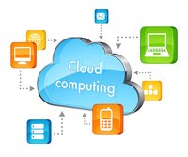
Cloud Computing tutorial provides basic and advanced concepts of Cloud Computing. Our Cloud Computing tutorial is designed for beginners and professionals.
Cloud computing is a virtualization-based technology that allows us to create, configure, and customize applications via an internet connection. The cloud technology includes a development platform, hard disk, software application, and database.

What is Cloud Computing
The term cloud refers to a network or the internet. It is a technology that uses remote servers on the internet to store, manage, and access data online rather than local drives. The data can be anything such as files, images, documents, audio, video, and more.
There are the following operations that we can do using cloud computing:
- Developing new applications and services
- Storage, back up, and recovery of data
- Hosting blogs and websites
- Delivery of software on demand
- Analysis of data
- Streaming videos and audios

Why Cloud Computing?
Small as well as large IT companies, follow the traditional methods to provide the IT infrastructure. That means for any IT company, we need a Server Room that is the basic need of IT companies.
In that server room, there should be a database server, mail server, networking, firewalls, routers, modem, switches, QPS (Query Per Second means how much queries or load will be handled by the server), configurable system, high net speed, and the maintenance engineers.
To establish such IT infrastructure, we need to spend lots of money. To overcome all these problems and to reduce the IT infrastructure cost, Cloud Computing comes into existence.
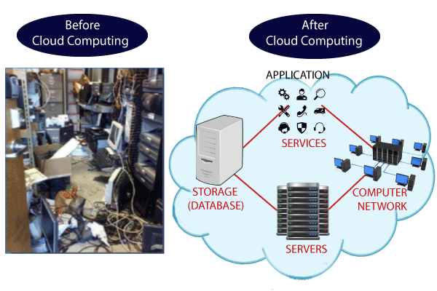

Characteristics of Cloud Computing
The characteristics of cloud computing are given below:
1) Agility
The cloud works in a distributed computing environment. It shares resources among users and works very fast.
2) High availability and reliability
The availability of servers is high and more reliable because the chances of infrastructure failure are minimum.
3) High Scalability
Cloud offers "on-demand" provisioning of resources on a large scale, without having engineers for peak loads.
4) Multi-Sharing
With the help of cloud computing, multiple users and applications can work more efficiently with cost reductions by sharing common infrastructure.
5) Device and Location Independence
Cloud computing enables the users to access systems using a web browser regardless of their location or what device they use e.g. PC, mobile phone, etc. As infrastructure is off-site (typically provided by a third-party) and accessed via the Internet, users can connect from anywhere.
6) Maintenance
Maintenance of cloud computing applications is easier, since they do not need to be installed on each user's computer and can be accessed from different places. So, it reduces the cost also.
7) Low Cost
By using cloud computing, the cost will be reduced because to take the services of cloud computing, IT company need not to set its own infrastructure and pay-as-per usage of resources.
8) Services in the pay-per-use mode
Application Programming Interfaces (APIs) are provided to the users so that they can access services on the cloud by using these APIs and pay the charges as per the usage of services.

Prerequisite
Before learning cloud computing, you must have the basic knowledge of computer fundamentals.

Audience
Our cloud computing is designed to help beginners and professionals.

Problem
We assure that you will not find any difficulty while learning our cloud computing tutorial. But if there is any mistake in this tutorial, kindly post the problem or error in the contact form.

Advantages and Disadvantages of Cloud Computing

Advantages of Cloud Computing
As we all know that Cloud computing is trending technology. Almost every company switched their services on the cloud to rise the company growth.
Here, we are going to discuss some important advantages of Cloud Computing-
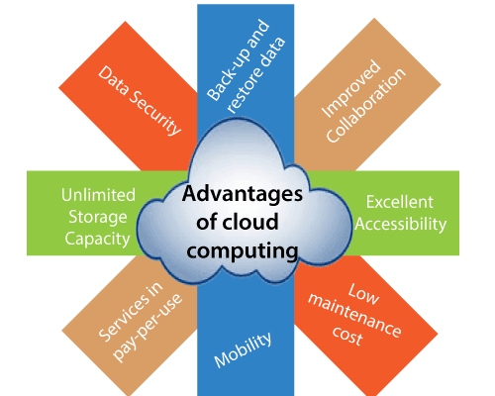

1) Back-up and restore data
Once the data is stored in the cloud, it is easier to get back-up and restore that data using the cloud.

2) Improved collaboration
Cloud applications improve collaboration by allowing groups of people to quickly and easily share information in the cloud via shared storage.

3) Excellent accessibility
Cloud allows us to quickly and easily access store information anywhere, anytime in the whole world, using an internet connection. An internet cloud infrastructure increases organization productivity and efficiency by ensuring that our data is always accessible.

4) Low maintenance cost
Cloud computing reduces both hardware and software maintenance costs for organizations.

5) Mobility
Cloud computing allows us to easily access all cloud data via mobile.

6) IServices in the pay-per-use model
Cloud computing offers Application Programming Interfaces (APIs) to the users for access services on the cloud and pays the charges as per the usage of service.

7) Unlimited storage capacity
Cloud offers us a huge amount of storing capacity for storing our important data such as documents, images, audio, video, etc. in one place.

8) Data security
Data security is one of the biggest advantages of cloud computing. Cloud offers many advanced features related to security and ensures that data is securely stored and handled.

Disadvantages of Cloud Computing
A list of the disadvantage of cloud computing is given below –

Internet Connectivity
As you know, in cloud computing, every data (image, audio, video, etc.) is stored on the cloud, and we access these data through the cloud by using the internet connection. If you do not have good internet connectivity, you cannot access these data. However, we have no any other way to access data from the cloud.

2) Vendor lock-in
Vendor lock-in is the biggest disadvantage of cloud computing. Organizations may face problems when transferring their services from one vendor to another. As different vendors provide different platforms, that can cause difficulty moving from one cloud to another.

3) Limited Control
As we know, cloud infrastructure is completely owned, managed, and monitored by the service provider, so the cloud users have less control over the function and execution of services within a cloud infrastructure.

4) Security
Although cloud service providers implement the best security standards to store important information. But, before adopting cloud technology, you should be aware that you will be sending all your organization’s sensitive information to a third party, i.e., a cloud computing service provider. While sending the data on the cloud, there may be a chance that your organization’s information is hacked by Hackers.

Types of Cloud
Cloud computing is a revolutionary technology transforming how we store, access, and process data. It simply refers to delivering computing resources, such as servers, storage, databases, software, and applications, over the Internet. Cloud computing uses a network of remote computer systems housed on the net to save and process data rather than relying on physical infrastructure.
Cloud service companies use advanced security techniques, which include encryption, firewalls, and access restrictions, to secure your data from unauthorized access. Moreover, because your information is saved in the cloud, it is secure even if your nearby devices are damaged, misplaced, or stolen. Redundancy and cloud backups guarantee that your data may be restored promptly and effectively in case of any unexpected situations.

Types of Cloud
There are the following 5 types of cloud that you can deploy according to the organization’s needs-
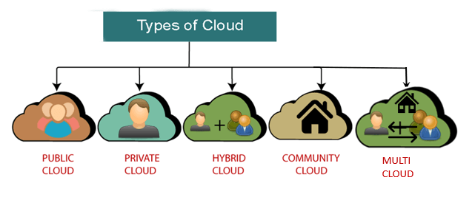
- Public Cloud
- Private Cloud
- Hybrid Cloud
- Community Cloud
- Multi Cloud

Public Cloud
Public cloud is open to all to store and access information via the Internet using the pay-per-usage method.
In public cloud, computing resources are managed and operated by the Cloud Service Provider (CSP). The CSP looks after the supporting infrastructure and ensures that the resources are accessible to and scalable for the users.
Due to its open architecture, anyone with an internet connection may use the public cloud, regardless of location or company size. Users can use the CSP's numerous services, store their data, and run apps. By using a pay-per-usage strategy, customers can be assured that they will only be charged for the resources they actually use, which is a smart financial choice.
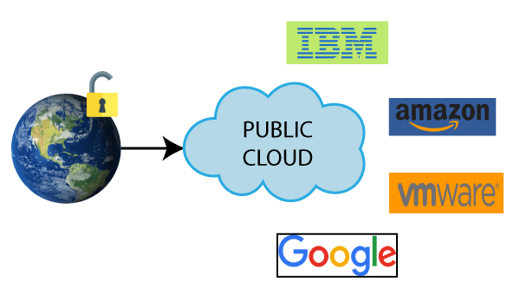
Example: Amazon elastic compute cloud (EC2), IBM SmartCloud Enterprise, Microsoft, Google App Engine, Windows Azure Services Platform.

Characteristics of Public Cloud
The public cloud has the following key characteristics:
- Accessibility: Public cloud services are available to anyone with an internet connection. Users can access their data and programs at any time and from anywhere.
- Shared Infrastructure: Several users share the infrastructure in public cloud settings. Cost reductions and effective resource use are made possible by this.
- Scalability: By using the public cloud, users can easily adjust the resources they need based on their requirements, allowing for quick scaling up or down.
- Pay-per-Usage: When using the public cloud, payment is based on usage, so users only pay for the resources they actually use. This helps optimize costs and eliminates the need for upfront investments.
- Managed by Service Providers: Cloud service providers manage and maintain public cloud infrastructure. They handle hardware maintenance, software updates, and security tasks, relieving users of these responsibilities.
- Reliability and Redundancy: Public cloud providers ensure high reliability by implementing redundant systems and multiple data centers. By doing this, the probability of losing data and experiencing service disruptions is reduced.
- Security Measures: Public cloud providers implement robust security measures to protect user data. These include encryption, access controls, and regular security audits.

Advantages of Public Cloud
There are the following advantages of Public Cloud -
- Public cloud is owned at a lower cost than the private and hybrid cloud.
- Public cloud is maintained by the cloud service provider, so do not need to worry about the maintenance.
- Public cloud is easier to integrate. Hence it offers a better flexibility approach to consumers.
- Public cloud is location independent because its services are delivered through the internet.
- Public cloud is highly scalable as per the requirement of computing resources.
- It is accessible by the general public, so there is no limit to the number of users.
- Rapid deployment of services and applications.
- Reduced time and effort in hardware procurement and setup.
- The cloud provider offers a range of services and resources that you can avail of.
- Built-in redundancy and resilience for enhanced reliability.

Disadvantages of Public Cloud
- Public Cloud is less secure because resources are shared publicly.
- Performance depends upon the high-speed internet network link to the cloud provider.
- The data is not under the control of the client.
- Dependency on the cloud service provider for availability and service level agreements.
- Compliance challenges in meeting industry-specific regulations and standards.
- Risk of vendor lock-in and limited portability of applications and data.
- Concerns about data privacy and confidentiality.
- Potential for unexpected costs with usage-based pricing models.
- Lack of customization options and flexibility compared to private or hybrid cloud environments.
- Reliance to the cloud provider's support and responsiveness for issue resolution.
To Read More Click Here

Private Cloud
Private cloud is also known as an internal cloud or corporate cloud. It is used by organizations to build and manage their own data centers internally or by the third party. It can be deployed using Opensource tools such as Openstack and Eucalyptus.
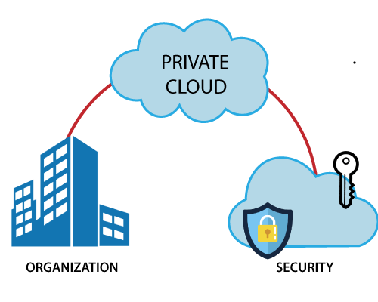
Examples: VMware vSphere, OpenStack, Microsoft Azure Stack, Oracle Cloud at Customer, and IBM Cloud Private.
Based on the location and management, National Institute of Standards and Technology (NIST) divide private cloud into the following two parts-
- On-premise private cloud: An on-premise private cloud is situated within the physical infrastructure of the organization. It involves setting up and running a specific data center that offers cloud services just for internal usage by the company. The infrastructure is still completely under the hands of the organization, which gives them the freedom to modify and set it up in any way they see fit. Organizations can successfully manage security and compliance issues with this degree of control. However, on-premise private cloud setup and management necessitate significant hardware, software, and IT knowledge expenditures.
- Outsourced private cloud: An outsourced private cloud involves partnering with a third-party service provider to host and manage the cloud infrastructure on behalf of the organization. The provider may operate the private cloud in their data center or a colocation facility. In this arrangement, the organization benefits from the expertise and resources of the service provider, alleviating the burden of infrastructure management. The outsourced private cloud model offers scalability, as the provider can adjust resources based on the organization's needs. Due to its flexibility, it is a desirable choice for businesses that desire the advantages of a private cloud deployment without the initial capital outlay and ongoing maintenance expenses involved with an on-premise implementation.
Compared to public cloud options, both on-premise and external private clouds give businesses more control over their data, apps, and security. Private clouds are particularly suitable for organizations with strict compliance requirements, sensitive data, or specialized workloads that demand high levels of customization and security.

Characteristics of Private Cloud
The private cloud has the following key characteristics:
- Exclusive Use: Private cloud is dedicated to a single organization, ensuring the resources and services are tailored to its needs. It is like having a personal cloud environment exclusively for that organization.
- Control and Security: Private cloud offers organizations higher control and security than public cloud options. Organizations have more control over data governance, access controls, and security measures.
- Customization and Flexibility: Private cloud allows organizations to customize the infrastructure according to their specific requirements. They can configure resources, networks, and storage to optimize performance and efficiency.
- Scalability and Resource Allocation: The private cloud can scale and allocate resources. According to demand, businesses may scale up or down their infrastructure, effectively using their resources.
- Performance and dependability: Private clouds give businesses more control over the infrastructure at the foundation, improving performance and dependability.
- Compliance and Regulatory Requirements: Organizations may more easily fulfill certain compliance and regulatory standards using the private cloud. It provides the freedom to put in place strong security measures, follow data residency laws, and follow industry-specific norms.
- Hybrid Cloud Integration: Private cloud can be integrated with public cloud services, forming a hybrid cloud infrastructure. This integration allows organizations to leverage the benefits of both private and public clouds.

Advantages of Private Cloud
There are the following advantages of the Private Cloud -
- Private cloud provides a high level of security and privacy to the users.
- Private cloud offers better performance with improved speed and space capacity.
- It allows the IT team to quickly allocate and deliver on-demand IT resources.
- The organization has full control over the cloud because it is managed by the organization itself. So, there is no need for the organization to depends on anybody.
- It is suitable for organizations that require a separate cloud for their personal use and data security is the first priority.
- Customizable to meet specific business needs and compliance regulations.
- Higher reliability and uptime compared to public cloud environments.
- Seamless integration with existing on-premises systems and applications.
- Better compliance and governance capabilities for industry-specific regulations.
- Enhanced flexibility in resource allocation and application deployment.

Disadvantages of Private Cloud
- Skilled people are required to manage and operate cloud services.
- Private cloud is accessible within the organization, so the area of operations is limited.
- Private cloud is not suitable for organizations that have a high user base, and organizations that do not have the prebuilt infrastructure, sufficient manpower to maintain and manage the cloud.
- Higher upfront costs and ongoing maintenance expenses.
- Scaling resources can be challenging compared to public or hybrid cloud options.
- Relies on internal IT staff for management and troubleshooting.
- Slower deployment timelines and implementation compared to public cloud solutions.
- Limited access to the latest advancements and innovations offered by public cloud providers.
- Reduced flexibility and agility compared to public cloud options.
- Challenges in keeping up with hardware and software upgrades and compatibility.
- Higher risks of technology becoming outdated and the need for regular infrastructure updates.
To Read More Click Here

Hybrid Cloud
Hybrid Cloud is a combination of the public cloud and the private cloud. we can say:
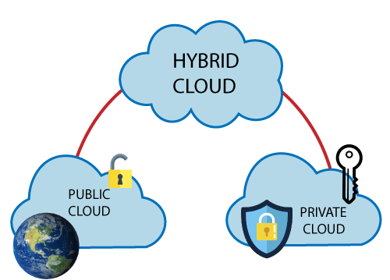
Hybrid Cloud = Public Cloud + Private Cloud
Hybrid cloud is partially secure because the services which are running on the public cloud can be accessed by anyone, while the services which are running on a private cloud can be accessed only by the organization's users. In a hybrid cloud setup, organizations can leverage the benefits of both public and private clouds to create a flexible and scalable computing environment. The public cloud portion allows using cloud services provided by third-party providers, accessible over the Internet.
Example: Google Application Suite (Gmail, Google Apps, and Google Drive), Office 365 (MS Office on the Web and One Drive), Amazon Web Services.

Characteristics of Hybrid Cloud
- Integration of Public and Private Clouds: Hybrid cloud seamlessly integrates public and private clouds, allowing organizations to leverage both advantages. It provides a unified platform where workloads and data can be deployed and managed across both environments.
- Flexibility and Scalability: Hybrid cloud offers resource allocation and scalability flexibility. Organizations can dynamically scale their infrastructure by utilizing additional resources from the public cloud while maintaining control over critical workloads on the private cloud.
- Enhanced Security and Control: Hybrid cloud allows organizations to maintain higher security and control over their sensitive data and critical applications. Private cloud components provide a secure and dedicated environment, while public cloud resources can be used for non-sensitive tasks, ensuring a balanced approach to data protection.
- Cost Optimization: Hybrid cloud enables organizations to optimize costs by utilizing the cost-effective public cloud for non-sensitive workloads while keeping mission-critical applications and data on the more cost-efficient private cloud. This approach allows for efficient resource allocation and cost management.
- Data and Application Portability: Organizations can move workloads and data between public and private clouds as needed with a hybrid cloud. This portability offers agility and the ability to adapt to changing business requirements, ensuring optimal performance and responsiveness.
- Compliance and Regulatory Compliance: Hybrid cloud helps organizations address compliance and regulatory requirements more effectively. Sensitive data and applications can be kept within the private cloud, ensuring compliance with industry-specific regulations while leveraging the public cloud for other non-sensitive operations.
- Disaster Recovery and Business Continuity: Hybrid cloud facilitates robust disaster recovery and business continuity strategies. Organizations can replicate critical data and applications between the private and public clouds, ensuring redundancy and minimizing the risk of data loss or service disruptions.

Advantages of Hybrid Cloud
There are the following advantages of Hybrid Cloud -
- Hybrid cloud is suitable for organizations that require more security than the public cloud.
- Hybrid cloud helps you to deliver new products and services more quickly.
- Hybrid cloud provides an excellent way to reduce the risk.
- Hybrid cloud offers flexible resources because of the public cloud and secure resources because of the private cloud.
- Hybrid facilitates seamless integration between on-premises infrastructure and cloud environments.
- Hybrid provides greater control over sensitive data and compliance requirements.
- Hybrid enables efficient workload distribution based on specific needs and performance requirements.
- Hybrid offers cost optimization by allowing organizations to choose the most suitable cloud platform for different workloads.
- Hybrid enhances business continuity and disaster recovery capabilities with private and public cloud resources.
- Hybrid supports hybrid cloud architecture, allowing applications and data to be deployed across multiple cloud environments based on their unique requirements.

Disadvantages of Hybrid Cloud
- In Hybrid Cloud, security feature is not as good as the private cloud.
- Managing a hybrid cloud is complex because it is difficult to manage more than one type of deployment model.
- In the hybrid cloud, the reliability of the services depends on cloud service providers.
- Potential challenges in data integration and ensuring seamless connectivity between different cloud platforms.
- Higher costs due to the need for managing and integrating multiple cloud environments.
- Increased complexity in data governance and compliance management across different cloud providers.
- Dependency on stable and high-bandwidth internet connections for efficient hybrid cloud operations.
- Potential compatibility issues between various cloud platforms and applications.
- Risk of vendor lock-in and limited portability of applications and data across different cloud providers.
- Requires skilled IT staff with expertise in managing hybrid cloud environments.
To Read More Click Here

Community Cloud
Community cloud allows systems and services to be accessible by a group of several organizations to share the information between the organization and a specific community. It is owned, managed, and operated by one or more organizations in the community, a third party, or a combination of them.
In a community cloud setup, the participating organizations, which can be from the same industry, government sector, or any other community, collaborate to establish a shared cloud infrastructure. This infrastructure allows them to access shared services, applications, and data relevant to their community.
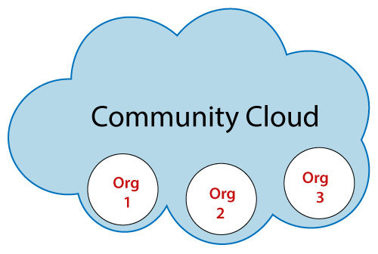
Example: Health Care community cloud

Characteristics of Community Cloud
- Shared Infrastructure: Community cloud provides a shared infrastructure accessible to a specific community of organizations. The participating organizations can leverage this common cloud infrastructure to meet their shared computing needs and objectives.
- Community-specific Services: The community cloud provides resources, apps, and services adapted to the participating organizations' demands. These services are created to meet the community's specific requirements and difficulties while promoting effective communication and information exchange.
- Community Ownership and Management: The community cloud is owned, managed, and operated by one or more organizations from the community, a third party, or a combination of both. The involved organizations have a say in the governance and decision-making procedures to ensure that the cloud infrastructure meets their shared objectives.
- Enhanced Security and Compliance: Community cloud emphasizes security and compliance measures relevant to the specific community. It allows for implementing robust security controls, access management, and compliance frameworks that meet the community's regulatory requirements and industry standards.
- Cost Sharing and Efficiency: Participating organizations in a community cloud benefit from cost sharing. By sharing the infrastructure and resources, the costs associated with establishing and maintaining the cloud environment are distributed among the community members. This leads to cost efficiency and reduced financial burden for individual organizations.
- Collaboration and Knowledge Sharing: The community cloud encourages communication and information exchange amongst participating businesses. It gives community members a forum for project collaboration, information sharing, and resource exploitation. This encourages creativity, education, and effectiveness within the neighborhood.
- Scalability and Flexibility: Community cloud enables organizations to scale up or reduce their resources in response to demand. This allows the community to adjust to shifting computing requirements and efficiently use cloud resources as needed.

Advantages of Community Cloud
There are the following advantages of Community Cloud -
- Community cloud is cost-effective because the whole cloud is being shared by several organizations or communities.
- Community cloud is suitable for organizations that want to have a collaborative cloud with more security features than the public cloud.
- It provides better security than the public cloud.
- It provdes collaborative and distributive environment.
- Community cloud allows us to share cloud resources, infrastructure, and other capabilities among various organizations.
- Offers customization options to meet the unique needs and requirements of the community.
- Simplifies compliance with industry-specific regulations and standards through shared security measures.
- Provides scalability and flexibility, allowing organizations to scale resources based on changing demands.
- Promotes efficient resource utilization, reducing wastage, and optimizing performance within the community.
- Enables organizations to leverage shared expertise and experiences, leading to improved decision-making and problem-solving.

Disadvantages of Community Cloud
- Community cloud is not a good choice for every organization.
- Security features are not as good as the private cloud.
- It is not suitable if there is no collaboration.
- The fixed amount of data storage and bandwidth is shared among all community members.
- Challenges in ensuring consistent performance and availability when multiple organizations share the same resources.
- Limited scalability options as the shared resources determine the community cloud's capacity.
- Potential conflicts of interest among community members regarding resource allocation and usage.
- Transparent governance and agreement frameworks are required to address potential disputes and ensure fair resource distribution.
- Inadequate technical support and service level agreements (SLAs) compared to private or public cloud options.
To Read More Click Here

Multi-Cloud
Multi-cloud is a strategy in cloud computing where companies utilize more than one cloud service provider or platform to meet their computing needs. It involves distributing workloads, applications, and statistics throughout numerous cloud environments consisting of public, private, and hybrid clouds.
Adopting a multi-cloud approach allows businesses to have the ability to select and leverage the most appropriate cloud services from different providers based on their specific necessities. This allows them to harness each provider's distinctive capabilities and services, mitigating the risk of relying solely on one vendor while benefiting from competitive pricing models. '
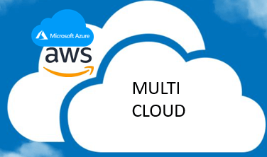
Examples: Amazon Web Services (AWS), Microsoft Azure, and Google Cloud Platform (GCP).

Characteristics of Multi-cloud
- Multiple Cloud Providers: The key characteristic of multi-cloud is the utilization of multiple cloud service providers. Organizations can leverage the offerings of different providers, such as Amazon web services (AWS), Microsoft Azure, Google Cloud Platform (GCP), and others, to access a huge range of services and capabilities.
- Diversification and Risk Reduction: Thanks to multi-cloud, organizations may distribute workloads, apps, and data across several cloud environments. This diversification decreases the danger of vendor lock-in, and the effects of any service interruptions or outages from a single cloud provider are lessened.
- Flexibility and Vendor Independence: Businesses using multi-cloud can choose the finest cloud services from various providers per their requirements. This approach enables companies to leverage each provider's unique benefits and avoids needing to depend solely on a single supplier for all their cloud computing requirements.
- Optimisation of Services and Costs: Organisations may optimize their services and costs by using a multi-cloud strategy and choosing the most affordable and appropriate cloud provider for each workload or application. They can use specialized services from many sources to meet certain demands, taking advantage of competitive pricing structures.
- Enhanced Reliability and Performance: Multi-cloud enhances reliability and performance by utilizing multiple cloud environments. By utilizing the infrastructure and resources of various providers, organizations can achieve high availability, scalability, and enhanced performance for their applications and services
- Data Sovereignty and Compliance: Multi-cloud allows organizations to address data sovereignty and compliance requirements by choosing cloud providers with data centers in specific regions or jurisdictions. It provides flexibility in managing data residency and regulatory compliance obligations.
- Interoperability and Integration: Multi-cloud necessitates interoperability and integration between different cloud platforms. Organizations must ensure seamless data exchange, application compatibility, and integration of services across the various cloud environments they utilize.

Advantages of Multi-Cloud:
There are the following advantages of multi-Cloud -
- It allows organizations to choose the most suitable cloud services from different providers based on their specific requirements.
- Distributing workloads and data across multiple cloud environments enhances reliability and ensures resilience in case of service disruptions or downtime.
- By utilizing its providers, organizations can avoid dependency on a single vendor and mitigate the risks associated with vendor lock-in.
- Organizations can optimize services and costs by selecting the most cost-effective and suitable cloud provider for each workload or application.
- Leveraging the infrastructure and resources of different cloud providers allows organizations to achieve high availability, scalability, and improved performance.
- It enables organizations to select cloud providers with data centers in specific regions, addressing data sovereignty and compliance requirements.
- Access to specialized services and capabilities from different providers promotes innovation and allows organizations to leverage the best-in-class offerings in the market.
- Distributing workloads across multiple clouds reduces the risk of data loss or service disruptions, providing enhanced disaster recovery capabilities.

Disadvantages of Multi-Cloud:
- Increased complexity in managing multiple cloud environments.
- Potential for higher costs due to multiple subscriptions and data transfer fees.
- Challenges in ensuring data governance and compliance across multiple clouds.
- Integration difficulties and compatibility issues between different cloud providers.
- Potential for increased management overhead and resource requirements.
- Risk of vendor dependencies and interoperability challenges.

Difference between public cloud, private cloud, hybrid cloud, and community cloud -
The below table shows the difference between public cloud, private cloud, hybrid cloud, and community cloud.
Parameter | Public Cloud | Private Cloud | Hybrid Cloud | Community Cloud | Multi-Cloud
Host | Service provider | Enterprise (Third party) | Enterprise (Third party) | Community (Third party) | Multiple cloud providers
Users | General public | Selected users | Selected users | Community members | Multiple organizations
Access | Internet | Internet, VPN | Internet, VPN | Internet, VPN | Internet, VPN
Owner | Service provider | Enterprise | Enterprise | Community | Multiple organizations
Cost | Pay-per-usage | Infrastructure investment | Mixed (variable) | Shared cost among members | Variable depending on usage
Security | Provider's responsibility | Enhanced control | Varied (depends on setup) | Varied (depends on setup) | Varied (depends on setup)
Scalability | Highly scalable | Scalable within resources | Scalable within resources | Scalable within resources | Scalable within resources
Customization | Limited control | High control | Varied (depends on setup) | Varied (depends on setup) | Varied (depends on setup)
Resource Sharing | Not shared | Not shared | Varied (depends on setup) | Shared among community | Shared among providers

Next TopicPublic Cloud

Cloud Service Models
There are the following three types of cloud service models -
- Infrastructure as a Service (IaaS)
- Platform as a Service (PaaS)
- Software as a Service (SaaS)
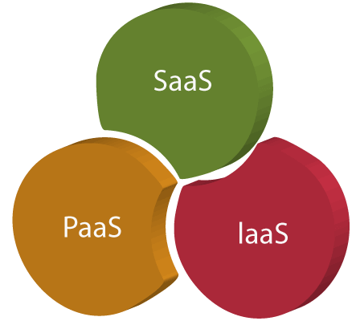

Infrastructure as a Service (IaaS)
IaaS is also known as Hardware as a Service (HaaS). It is a computing infrastructure managed over the internet. The main advantage of using IaaS is that it helps users to avoid the cost and complexity of purchasing and managing the physical servers.

Characteristics of IaaS
There are the following characteristics of IaaS -
- Resources are available as a service
- Services are highly scalable
- Dynamic and flexible
- GUI and API-based access
- Automated administrative tasks
Example: DigitalOcean, Linode, Amazon Web Services (AWS), Microsoft Azure, Google Compute Engine (GCE), Rackspace, and Cisco Metacloud.
To know more about the IaaS, click here.

Platform as a Service (PaaS)
PaaS cloud computing platform is created for the programmer to develop, test, run, and manage the applications.

Characteristics of PaaS
There are the following characteristics of PaaS -
- Accessible to various users via the same development application.
- Integrates with web services and databases.
- Builds on virtualization technology, so resources can easily be scaled up or down as per the organization's need.
- Support multiple languages and frameworks.
- Provides an ability to "Auto-scale".
Example: AWS Elastic Beanstalk, Windows Azure, Heroku, Force.com, Google App Engine, Apache Stratos, Magento Commerce Cloud, and OpenShift.
To know more about PaaS, click here.

Software as a Service (SaaS)
SaaS is also known as "on-demand software". It is a software in which the applications are hosted by a cloud service provider. Users can access these applications with the help of internet connection and web browser.

Characteristics of SaaS
There are the following characteristics of SaaS -
- Managed from a central location
- Hosted on a remote server
- Accessible over the internet
- Users are not responsible for hardware and software updates. Updates are applied automatically.
- The services are purchased on the pay-as-per-use basis
Example: BigCommerce, Google Apps, Salesforce, Dropbox, ZenDesk, Cisco WebEx, ZenDesk, Slack, and GoToMeeting.
To know more about the SaaS, click here.

Difference between IaaS, PaaS, and SaaS
The below table shows the difference between IaaS, PaaS, and SaaS -
IaaS | Paas | SaaS
It provides a virtual data center to store information and create platforms for app development, testing, and deployment. | It provides virtual platforms and tools to create, test, and deploy apps. | It provides web software and apps to complete business tasks.
It provides access to resources such as virtual machines, virtual storage, etc. | It provides runtime environments and deployment tools for applications. | It provides software as a service to the end-users.
It is used by network architects. | It is used by developers. | It is used by end users.
IaaS provides only Infrastructure. | PaaS provides Infrastructure+Platform. | SaaS provides Infrastructure+Platform +Software.

Infrastructure as a Service | IaaS
Iaas is also known as Hardware as a Service (HaaS). It is one of the layers of the cloud computing platform. It allows customers to outsource their IT infrastructures such as servers, networking, processing, storage, virtual machines, and other resources. Customers access these resources on the Internet using a pay-as-per use model.
In traditional hosting services, IT infrastructure was rented out for a specific period of time, with pre-determined hardware configuration. The client paid for the configuration and time, regardless of the actual use. With the help of the IaaS cloud computing platform layer, clients can dynamically scale the configuration to meet changing requirements and are billed only for the services actually used.
IaaS cloud computing platform layer eliminates the need for every organization to maintain the IT infrastructure.
IaaS is offered in three models: public, private, and hybrid cloud. The private cloud implies that the infrastructure resides at the customer-premise. In the case of public cloud, it is located at the cloud computing platform vendor's data center, and the hybrid cloud is a combination of the two in which the customer selects the best of both public cloud or private cloud.
IaaS provider provides the following services -
- Compute: Computing as a Service includes virtual central processing units and virtual main memory for the Vms that is provisioned to the end- users.
- Storage: IaaS provider provides back-end storage for storing files.
- Network: Network as a Service (NaaS) provides networking components such as routers, switches, and bridges for the Vms.
- Load balancers: It provides load balancing capability at the infrastructure layer.
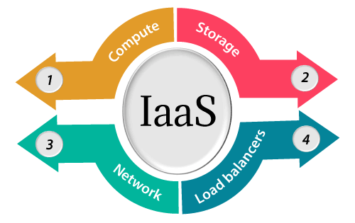

Advantages of IaaS cloud computing layer
There are the following advantages of IaaS computing layer -
1. Shared infrastructure
IaaS allows multiple users to share the same physical infrastructure.
2. Web access to the resources
Iaas allows IT users to access resources over the internet.
3. Pay-as-per-use model
IaaS providers provide services based on the pay-as-per-use basis. The users are required to pay for what they have used.
4. Focus on the core business
IaaS providers focus on the organization's core business rather than on IT infrastructure.
5. On-demand scalability
On-demand scalability is one of the biggest advantages of IaaS. Using IaaS, users do not worry about to upgrade software and troubleshoot the issues related to hardware components.

Disadvantages of IaaS cloud computing layer
1. Security
Security is one of the biggest issues in IaaS. Most of the IaaS providers are not able to provide 100% security.
2. Maintenance & Upgrade
Although IaaS service providers maintain the software, but they do not upgrade the software for some organizations.
3. Interoperability issues
It is difficult to migrate VM from one IaaS provider to the other, so the customers might face problem related to vendor lock-in.

Some important point about IaaS cloud computing layer
IaaS cloud computing platform cannot replace the traditional hosting method, but it provides more than that, and each resource which are used are predictable as per the usage.
IaaS cloud computing platform may not eliminate the need for an in-house IT department. It will be needed to monitor or control the IaaS setup. IT salary expenditure might not reduce significantly, but other IT expenses can be reduced.
Breakdowns at the IaaS cloud computing platform vendor's can bring your business to the halt stage. Assess the IaaS cloud computing platform vendor's stability and finances. Make sure that SLAs (i.e., Service Level Agreement) provide backups for data, hardware, network, and application failures. Image portability and third-party support is a plus point.
The IaaS cloud computing platform vendor can get access to your sensitive data. So, engage with credible companies or organizations. Study their security policies and precautions.

Top Iaas Providers who are providing IaaS cloud computing platform
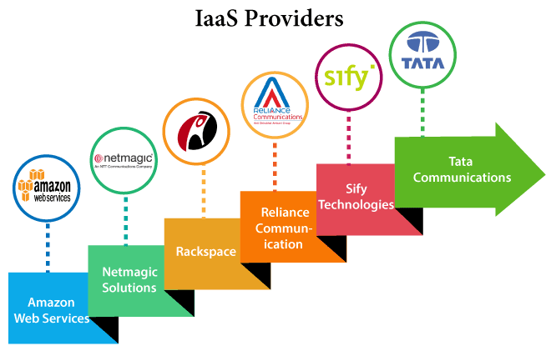
IaaS Vendor | Iaas Solution | Details
Amazon Web Services | Elastic, Elastic Compute Cloud (EC2) MapReduce, Route 53, Virtual Private Cloud, etc. | The cloud computing platform pioneer, Amazon offers auto scaling, cloud monitoring, and load balancing features as part of its portfolio.
Netmagic Solutions | Netmagic IaaS Cloud | Netmagic runs from data centers in Mumbai, Chennai, and Bangalore, and a virtual data center in the United States. Plans are underway to extend services to West Asia.
Rackspace | Cloud servers, cloud files, cloud sites, etc. | The cloud computing platform vendor focuses primarily on enterprise-level hosting services.
Reliance Communications | Reliance Internet Data Center | RIDC supports both traditional hosting and cloud services, with data centers in Mumbai, Bangalore, Hyderabad, and Chennai. The cloud services offered by RIDC include IaaS and SaaS.
Sify Technologies | Sify IaaS | Sify's cloud computing platform is powered by HP's converged infrastructure. The vendor offers all three types of cloud services: IaaS, PaaS, and SaaS.
Tata Communications | InstaCompute | InstaCompute is Tata Communications' IaaS offering. InstaCompute data centers are located in Hyderabad and Singapore, with operations in both count

Platform as a Service | PaaS
Platform as a Service (PaaS) provides a runtime environment. It allows programmers to easily create, test, run, and deploy web applications. You can purchase these applications from a cloud service provider on a pay-as-per use basis and access them using the Internet connection. In PaaS, back end scalability is managed by the cloud service provider, so end- users do not need to worry about managing the infrastructure.
PaaS includes infrastructure (servers, storage, and networking) and platform (middleware, development tools, database management systems, business intelligence, and more) to support the web application life cycle.
Example: Google App Engine, Force.com, Joyent, Azure.
PaaS providers provide the Programming languages, Application frameworks, Databases, and Other tools:
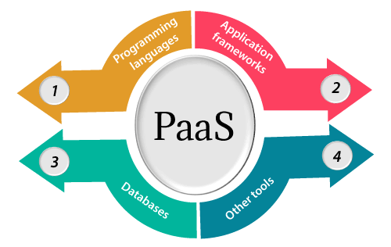

1. Programming languages
PaaS providers provide various programming languages for the developers to develop the applications. Some popular programming languages provided by PaaS providers are Java, PHP, Ruby, Perl, and Go.

2. Application frameworks
PaaS providers provide application frameworks to easily understand the application development. Some popular application frameworks provided by PaaS providers are Node.js, Drupal, Joomla, WordPress, Spring, Play, Rack, and Zend.

3. Databases
PaaS providers provide various databases such as ClearDB, PostgreSQL, MongoDB, and Redis to communicate with the applications.

4. Other tools
PaaS providers provide various other tools that are required to develop, test, and deploy the applications.

Advantages of PaaS
There are the following advantages of PaaS -
1) Simplified Development
PaaS allows developers to focus on development and innovation without worrying about infrastructure management.
2) Lower risk
No need for up-front investment in hardware and software. Developers only need a PC and an internet connection to start building applications.
3) Prebuilt business functionality
Some PaaS vendors also provide already defined business functionality so that users can avoid building everything from very scratch and hence can directly start the projects only.
4) Instant community
PaaS vendors frequently provide online communities where the developer can get the ideas to share experiences and seek advice from others.
5) Scalability
Applications deployed can scale from one to thousands of users without any changes to the applications.

Disadvantages of PaaS cloud computing layer
1) Vendor lock-in
One has to write the applications according to the platform provided by the PaaS vendor, so the migration of an application to another PaaS vendor would be a problem.
2) Data Privacy
Corporate data, whether it can be critical or not, will be private, so if it is not located within the walls of the company, there can be a risk in terms of privacy of data.
3) Integration with the rest of the systems applications
It may happen that some applications are local, and some are in the cloud. So there will be chances of increased complexity when we want to use data which in the cloud with the local data.

Popular PaaS Providers
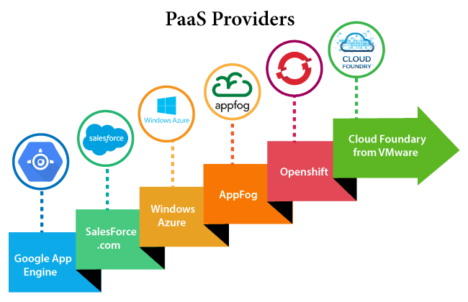
The below table shows some popular PaaS providers and services that are provided by them -
Providers | Services
Google App Engine (GAE) | App Identity, URL Fetch, Cloud storage client library, Logservice
Salesforce.com | Faster implementation, Rapid scalability, CRM Services, Sales cloud, Mobile connectivity, Chatter.
Windows Azure | Compute, security, IoT, Data Storage.
AppFog | Justcloud.com, SkyDrive, GoogleDocs
Openshift | RedHat, Microsoft Azure.
Cloud Foundry from VMware | Data, Messaging, and other services.

Software as a Service | SaaS
SaaS is also known as "On-Demand Software". It is a software distribution model in which services are hosted by a cloud service provider. These services are available to end-users over the internet so, the end-users do not need to install any software on their devices to access these services.
There are the following services provided by SaaS providers -
Business Services - SaaS Provider provides various business services to start-up the business. The SaaS business services include ERP (Enterprise Resource Planning), CRM (Customer Relationship Management), billing, and sales.
Document Management - SaaS document management is a software application offered by a third party (SaaS providers) to create, manage, and track electronic documents.
Example: Slack, Samepage, Box, and Zoho Forms.
Social Networks - As we all know, social networking sites are used by the general public, so social networking service providers use SaaS for their convenience and handle the general public's information.
Mail Services - To handle the unpredictable number of users and load on e-mail services, many e-mail providers offering their services using SaaS.
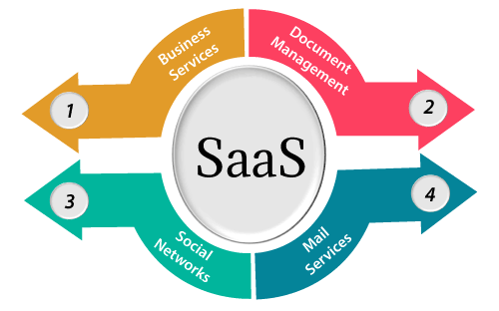

Advantages of SaaS cloud computing layer
1) SaaS is easy to buy
SaaS pricing is based on a monthly fee or annual fee subscription, so it allows organizations to access business functionality at a low cost, which is less than licensed applications.
Unlike traditional software, which is sold as a licensed based with an up-front cost (and often an optional ongoing support fee), SaaS providers are generally pricing the applications using a subscription fee, most commonly a monthly or annually fee.
2. One to Many
SaaS services are offered as a one-to-many model means a single instance of the application is shared by multiple users.
3. Less hardware required for SaaS
The software is hosted remotely, so organizations do not need to invest in additional hardware.
4. Low maintenance required for SaaS
Software as a service removes the need for installation, set-up, and daily maintenance for the organizations. The initial set-up cost for SaaS is typically less than the enterprise software. SaaS vendors are pricing their applications based on some usage parameters, such as a number of users using the application. So SaaS does easy to monitor and automatic updates.
5. No special software or hardware versions required
All users will have the same version of the software and typically access it through the web browser. SaaS reduces IT support costs by outsourcing hardware and software maintenance and support to the IaaS provider.
6. Multidevice support
SaaS services can be accessed from any device such as desktops, laptops, tablets, phones, and thin clients.
7. API Integration
SaaS services easily integrate with other software or services through standard APIs.
8. No client-side installation
SaaS services are accessed directly from the service provider using the internet connection, so do not need to require any software installation.

Disadvantages of SaaS cloud computing layer
1) Security
Actually, data is stored in the cloud, so security may be an issue for some users. However, cloud computing is not more secure than in-house deployment.
2) Latency issue
Since data and applications are stored in the cloud at a variable distance from the end-user, there is a possibility that there may be greater latency when interacting with the application compared to local deployment. Therefore, the SaaS model is not suitable for applications whose demand response time is in milliseconds.
3) Total Dependency on Internet
Without an internet connection, most SaaS applications are not usable.
4) Switching between SaaS vendors is difficult
Switching SaaS vendors involves the difficult and slow task of transferring the very large data files over the internet and then converting and importing them into another SaaS also.

Popular SaaS Providers
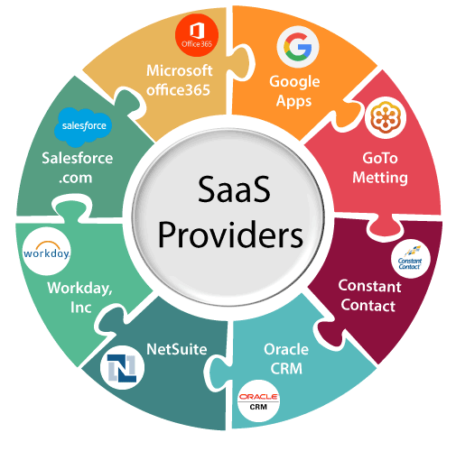
The below table shows some popular SaaS providers and services that are provided by them -
Provider | Services
Salseforce.com | On-demand CRM solutions
Microsoft Office 365 | Online office suite
Google Apps | Gmail, Google Calendar, Docs, and sites
NetSuite | ERP, accounting, order management, CRM, Professionals Services Automation (PSA), and e-commerce applications.
GoToMeeting | Online meeting and video-conferencing software
Constant Contact | E-mail marketing, online survey, and event marketing
Oracle CRM | CRM applications
Workday, Inc | Human capital management, payroll, and financial management.

Cloud Computing Architecture
As we know, cloud computing technology is used by both small and large organizations to store the information in cloud and access it from anywhere at anytime using the internet connection.
Cloud computing architecture is a combination of service-oriented architecture and event-driven architecture.
Cloud computing architecture is divided into the following two parts -
- Front End
- Back End
The below diagram shows the architecture of cloud computing -
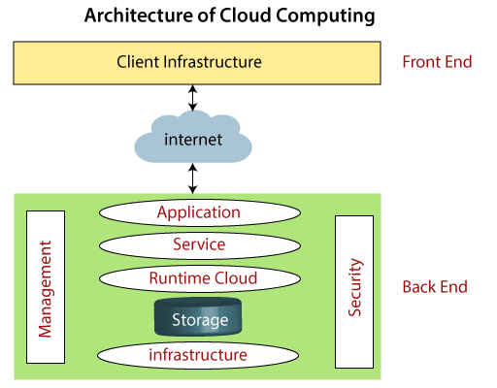

Front End
The front end is used by the client. It contains client-side interfaces and applications that are required to access the cloud computing platforms. The front end includes web servers (including Chrome, Firefox, internet explorer, etc.), thin & fat clients, tablets, and mobile devices.

Back End
The back end is used by the service provider. It manages all the resources that are required to provide cloud computing services. It includes a huge amount of data storage, security mechanism, virtual machines, deploying models, servers, traffic control mechanisms, etc.

Note: Both front end and back end are connected to others through a network, generally using the internet connection.

Components of Cloud Computing Architecture
There are the following components of cloud computing architecture –

1. Client Infrastructure
Client Infrastructure is a Front end component. It provides GUI (Graphical User Interface) to interact with the cloud.
2. Application
The application may be any software or platform that a client wants to access.
3. Service
A Cloud Services manages that which type of service you access according to the client’s requirement.
Cloud computing offers the following three type of services:
i. Software as a Service (SaaS) – It is also known as cloud application services. Mostly, SaaS applications run directly through the web browser means we do not require to download and install these applications. Some important example of SaaS is given below –
Example: Google Apps, Salesforce Dropbox, Slack, Hubspot, Cisco WebEx.
ii. Platform as a Service (PaaS) – It is also known as cloud platform services. It is quite similar to SaaS, but the difference is that PaaS provides a platform for software creation, but using SaaS, we can access software over the internet without the need of any platform.
Example: Windows Azure, Force.com, Magento Commerce Cloud, OpenShift.
iii. Infrastructure as a Service (IaaS) – It is also known as cloud infrastructure services. It is responsible for managing applications data, middleware, and runtime environments.
Example: Amazon Web Services (AWS) EC2, Google Compute Engine (GCE), Cisco Metapod.
4. Runtime Cloud
Runtime Cloud provides the execution and runtime environment to the virtual machines.
5. Storage
Storage is one of the most important components of cloud computing. It provides a huge amount of storage capacity in the cloud to store and manage data.
6. Infrastructure
It provides services on the host level, application level, and network level. Cloud infrastructure includes hardware and software components such as servers, storage, network devices, virtualization software, and other storage resources that are needed to support the cloud computing model.
7. Management
Management is used to manage components such as application, service, runtime cloud, storage, infrastructure, and other security issues in the backend and establish coordination between them.
8. Security
Security is an in-built back end component of cloud computing. It implements a security mechanism in the back end.
9. Internet
The Internet is medium through which front end and back end can interact and communicate with each other.

Cloud Computing Infrastructure

Cloud infrastructure consists of servers, storage devices, network, cloud management software, deployment software, and platform virtualization.
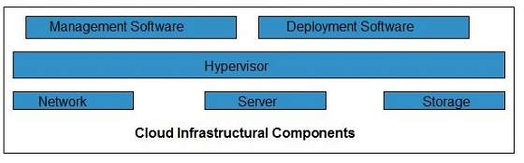

Hypervisor
Hypervisor is a firmware or low-level program that acts as a Virtual Machine Manager. It allows to share the single physical instance of cloud resources between several tenants.

Management Software
It helps to maintain and configure the infrastructure.

Deployment Software
It helps to deploy and integrate the application on the cloud.

Network
It is the key component of cloud infrastructure. It allows to connect cloud services over the Internet. It is also possible to deliver network as a utility over the Internet, which means, the customer can customize the network route and protocol.

Server
The server helps to compute the resource sharing and offers other services such as resource allocation and de-allocation, monitoring the resources, providing security etc.

Storage
Cloud keeps multiple replicas of storage. If one of the storage resources fails, then it can be extracted from another one, which makes cloud computing more reliable.

Infrastructural Constraints
Fundamental constraints that cloud infrastructure should implement are shown in the following diagram:
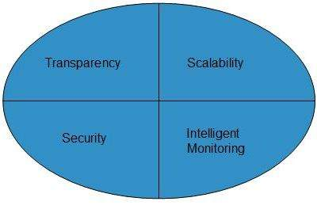

Transparency
Virtualization is the key to share resources in cloud environment. But it is not possible to satisfy the demand with single resource or server. Therefore, there must be transparency in resources, load balancing and application, so that we can scale them on demand.

Scalability
Scaling up an application delivery solution is not that easy as scaling up an application because it involves configuration overhead or even re-architecting the network. So, application delivery solution is need to be scalable which will require the virtual infrastructure such that resource can be provisioned and de-provisioned easily.

Intelligent Monitoring
To achieve transparency and scalability, application solution delivery will need to be capable of intelligent monitoring.

Security
The mega data center in the cloud should be securely architected. Also the control node, an entry point in mega data center, also needs to be secure.

cloud IDE

By
- Kathleen Casey, Site Editor

What is a cloud IDE?
A cloud IDE is a web-based integrated development platform.
A cloud-based IDE is a programming environment that has been packaged as an application, typically consisting of a code editor, a compiler, a debugger and a graphical user interface (GUI) builder. Enterprises can either create a new IDE to run only in the cloud or transform a local IDE to run in cloud.
Frequently, these IDEs are not only cloud-based but also designed for the creation of cloud apps. However, some cloud IDEs are optimized for the creation of native apps for smartphones, tablets and other mobile devices.

Benefits and drawbacks of a cloud-based IDE
One of the main benefits of cloud-based IDEs is they are accessible from anywhere in the world, from any compatible device, via remote access. This enables better collaboration among geographically dispersed developers. Other benefits include the following:
- easier setup process
- standardized workspaces
- reduced project times
- cost savings
However, some drawbacks include the following:
- latency
- change in culture
- vender lock-in
The emergence of HTML 5 is often cited as a key enabler of cloud IDEs because that standard supports browser-based development. Other key factors include the increasing trends toward portability, cloud computing and open source software.
Popular cloud-native IDEs include AWS Cloud9, Google Cloud Shell Editor and Microsoft Azure Notebooks. Some third-part options include Codeanywhere, Repl.it and Codenvy.

